Abstract

This paper talks about the GDP, and comparison of different countries on based on GDP and its factor to calculate GDP we took variables like agriculture sector , service sector and industry to measure the GDP of different countries of the world. we uses the research paper of BRICS and economics perspective of artificial intelligence to proceed with our research work. After that we have discuss the case study of about growth of china GDP.

1 Introduction

Gross Domestic Product (GDP), describes the total market value of all final goods and services produced within a given time period by factors of production located within a country. GDP does not include intermediate goods, but only “new” products and services GDP can be calculated in three different ways, firstly by value added (or production) approach, which adds up the gross output of different industries and then subtracts intermediate inputs. Secondly it can be calculated by income approach, which measures the income earned by different factors of production. Lastly the GDP can be determined by final demand (or expenditures) approach, which measures the activities, such as investment and consumption across different industries and imports deducted from exports.

GDP = C + I + G + (X – M)

C is consumption of final goods and services by households

I is investment in things such as plants, equipment and software

G is government expenditures on goods and services

X is exports

M is imports

The GDP of a country is calculated by adding the following figures together: personal consumption; private investment; government spending; and exports (less imports).

GDP for Economists and Investors

GDP is an important measurement for economists and investors because it is a representation of economic production and growth. Both economic production and growth have a large impact on nearly everyone within a given economy. When the economy is healthy, there is usually a lower level of unemployment, and wages tend to increase as businesses hire more labor to meet the growing demand of the economy. Economists look at positive GDP growth between different time periods (usually year-to-year) to make an assessment of how much an economy is flourishing. Conversely, if there is negative GDP growth, it may be an indicator that an economy is in or approaching a recession or an economic downturn.

Investors pay attention to the GDP because a significant percentage change in the GDP–either up or down–can have a significant impact on the stock market. In general, a bad economy usually means lower earnings for companies. And this can translate into lower stock prices.

An economic perspective on Artificial Intelligence

Artificial intelligence (AI) technology has significantly improved rapidly over the last decade, generating

excitement and concern . While such machines may one day be achievable, most people struggle

to understand the importance and advantage of artificial intelligence. In this way, we can better understand both its advantage and its implications. Technological progress makes certain tasks more cheaper. It is useful to understand artificial intelligence as making prediction more affordable. Such affordable technology, in turn, becomes more pervasive as new opportunities to use the technology arise. When technology becomes cheaper, demand also increases . In the case of prediction technology, a key complement is judgment, or the ability to understand payoffs. Last ,technological change leads to organizational changes. This happened since the industrial

Revolution with the engine and electricity: the same is likely to happen with artificial

intelligence and machine learning. But organizational change is not easy .

Technological change and cost

Artificial intelligence is generating various expectations as well as concerns. , like

Elon Musk, believe that intelligent machines will be much smarter than human beings

Several consulting companies like Accenture or PricewaterhouseCoopers (PwC) are much more optimistic, predicting that artificial intelligence will add several billion dollars to the global economy in the future. The debate about artificial intelligence is, however, nebulous. The primary technology underlying the current excitement in AI is machine learning. Machine learning can be understood same as prediction technology. Prediction is the process of filling in missing information. It uses available information (or data) to predict unavailable or unknown information. This new information can inform predictions about the future but Recent advances in artificial intelligence have led to more accurate, faster, and cheaper prediction. soft Computing, arithmetic provides an example. Computers are used for many tasks, but in reality they are just a tool for arithmetic: they handle numerous calculations at vey fast speed . Once arithmetic became cheap enough, we started to use it much more, Cheap arithmetic meant that these tasks could be done at greater speed and better accuracy than when carried out by human beings. Over time, the cost of arithmetic dip further. Another example is provided by the field of photography: until the 1990s, the problem was largely based on a chemical one. Kodak, , was a chemical company. As the price of arithmetic fell, however, it became feasible to treat photography as an arithmetic problem to be solved by computers. Similarly, music recording was mixture of chemistry and physics. About 200 years ago, Ada Lovelace find that many of these problems could be solved by arithmetic. This happened when arithmetic became cheap enough.

Building Better Global Economic BRICs

In 2001 and 2002, the real GDP growth in large emerging market economies will exceed that

of the G7.At end-2000, GDP in US$ on a PPP basis in Brazil, Russia, India and China (BRIC) was

about 23.3% of world GDP. On a current GDP basis, BRIC share of world GDP is 8%. Using current GDP, China’s GDP is higher than that of Italy. Over the next 10 years, the weight of the BRICs and especially China in world GDP will grow, raising an important issues about the global economic impact of fiscal and monetary policy in the BRICs.(according to JIM’O NEILL)

In This paper we discusses the state of the world economy as we approach towards an year-end, with emphasis on the relationship between the G7 and some of the larger emerging market economies.

We show that our latest forecasts for 2001 and 2002 suggest a healthier outlook in some of the larger emerging market economies compared to the G7. We are currently forecasting 1.7% world GDP growth in 2002 with Brazil, Russia, India and China (BRICs)

On a PPP basis, the aggregate size of the BRICs was about 23.3% of world GDP near the end of 2000, higher than Japan. While on a current GDP basis, the size of the BRICs is just under 8%, this is also set to rise. Some of these countries are already bigger G7 economies; China, at 3.6% of world GDP (using current US$ prices), was slightly higher than Italy at the end of 2000, and larger than Canada.

We consider four different scenarios for the next decade based on nominal GDP assumptions for 11 countries (the G7 and BRICs),. The nominal GDP assumptions guesses about the likely trend rate of real GDP growth and inflation.

In Scenario A, we convert future nominal GDP projections at end-2000 exchange rates.

In Scenario B, we convert GDP projections using our GSDEER/GSDEEMER fair value exchange rate

estimates.

Scenario C again converts at end-2000 exchange rates, but assumes that the 2001/2002 nominal GDP paths continue for 10 years.

Scenario D converts projected GDP trends using PPP conversions rather than estimated end-2011 current US Dollars.

In all four scenarios, the relative weight of the BRICs rises from 8.0% at present (in current US$) to 14.2%, or from 23.3% to 27.0%, converting at PPP rates. the increasing weight is led by China, although the other three grow relative to the G7 countries also.

We also show our latest projections for likely timing of future EU joiners and subsequent membership of

EMU. We suggest that there is a 50% or greater probability of another 13 countries becoming active members of EMU by 2007, taking the total membership to 25 from today’s 12.

We discuss that with 25 members of EMU, it is necessary to reform the ‘active’ membership of the ECB .Governing Council and recommend instead the introduction of an ‘FOMC-like’ rotating voting mechanism. In view of the continued relative growth of the BRICs, the opportunity should be taken to incorporate China, Brazil, Russia and India, expanding the key body of global economic policy .

. 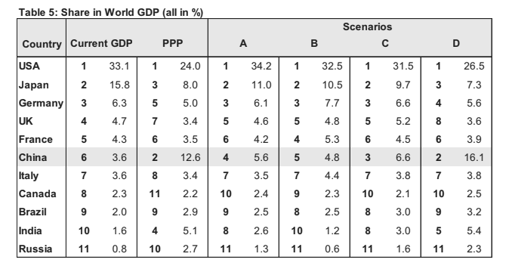

WHO EXACTLY IS THE G7?

Group of Seven (G7) emerged from the G5, itself an entity that seemed to emerge in April 1973 following a meeting between the current Finance Ministers of the US, Germany and France-George P. Schultz, Helmut Schmidt and Valerie Giscard d’Estaing. This meeting, breakdown of Bretton Woods and focused on the resulting international monetary crisis, laid the foundation for the Group of Five (G5).Two participants, Schmidt and d’Estaing, went on to become leaders of their countries, Germany and France. They were eager to pursue direct contacts of a similar nature on a regular basis and according to Funabashi1 ,the Helsinki Conference of July 1975 provided an occasion for them to pursue their G5 agenda. Soon after, on November 15-17th France hosted a summit at Rambouillet in France and they and Italy, Germany, the UK and US, together with Japan and Italy, discussed a range of economic and political issues. The regular annual Heads of Summit from then on took place on a G7 basis, with Canada being included. Typically, the Finance Ministers of the G5 (excluding Italy and Canada) met separately., although their subjects and style was often prompted by world economic circumstances. Perhaps its most famous act of influence on the world financial stage was the ‘Plaza Accord’ of September 1985, at which they agreed to deliberately weaken the value of the Dollar.

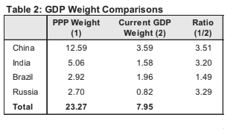

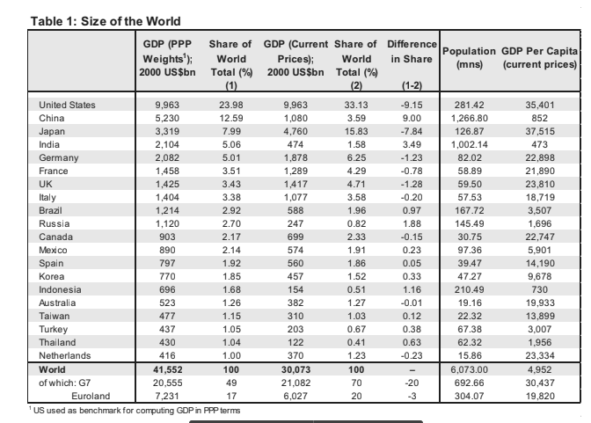

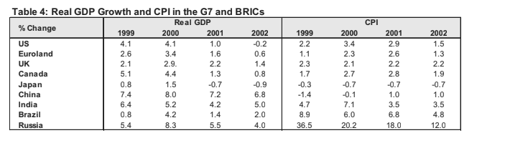

Scenario A simply exploits nominal GDP for the next decade on the very crude assumption that

exchange rates will be the same level as at end-2000. The most interesting thing here is the rise in the

China to the 5th position largest economy. The combined weight of the BRICs jumps to 12.0%.

Scenario B repeats the same exercise of the previous scenario, but converts the local GDP into current

US$ using our long-term GSDEER and GSDEEMER values

This scenario raises the weighting of the Eurozone countries due to the strong undervaluation of the Euro

according to our GSDEER model, but generally the results are no different to the current situation. The

combined weight of the BRICs rises to 9.1%

Scenario C considers the scenario discussed earlier when the 2001/02 economic situation is same for

the next decade, where relative nominal GDP growth is higher in the BRICs than the G7 countries.

the other interesting observation., the weight of the BRICs rises to 14.2%.

Scenario D considers nominal GDP growth adjusted for PPP developments.

Based our assumptions, once more China appears very large relative to some

other countries, more than two times the size of Japan and being larger than the combined size of France, Germany and Italy. After this BRIC weight rises to 27.0%.

As learn from the above four scenerio, all result in China’s relative standing in the world GDP league

tables considerably stronger than today.

WILL CHINA GROW OLD BEFORE GETTING RICH?

China’s economic growth over the past -century has surpassed all records

With an average annual

real GDP growth rate of 9.6% from 1978 to 2004, China’s pace of growth is faster than that

any East Asian countries . Two forces are behind these changes: 1) increased longevity, which raising the number of elderly,

and 2) the one-child policy, which has slowed the growth rate of young adults in the

population. The implication for workforce growth is immediate and significant. When more

workers reach retirement age and growth of the young adult population slows, the dependent per-worker ratio will increase

Our research suggests that by the time China becomes an eaged society till 2027, it will

probably be considered a developed country, although it will still be considerably poorer than

the US or Japan on a per-capita income basis. We believe the rapid build-up of human capital

and the continued release of surplus labour from the agriculture sector will mitigate the

negative influences on the labour supply from ageing.

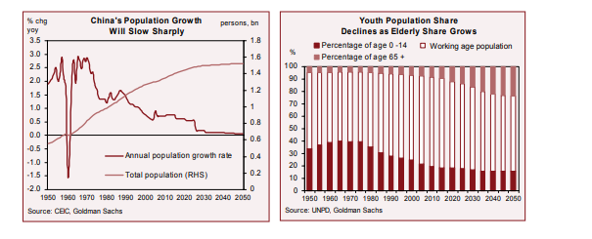

China's Labour-Force Dynamics Slower population growth, ageing And a rising dependency ratio

China’s average population growth from 1950 to 1978 was 2.01% per year. After that population growth has slowed substantially. From 1979 to 2004, growth averaged 1.16% per year. By 2005, the population growth rate had fallen to about 0.65%, half the world average and just roughly one-third of its level 50 years ago.Ageing is been a hidden problem in China. Since 1980, the elderly population has been growing faster than the average of the world and Asia. Yet here the ageing was not considered a serious problem 20 years ago, because there was a large number of young people aged 0-15 who could rapidly replaced the elderly exiting the labour force. But when this Reserve of young people is drained and the elderly surpass the rest of the age groups in growth significantly.

Unleashing Surplus Labour

China’s agricultural productivity has increase since the early 1980s, but its

growth are lagged behind as that of industrial productivity. Labour productivity in the industrial

sector grew two times as fast as in agriculture during 1979-2004.

This partly due to less capital and poorer technology compared with other sectors, and due to the lower number of labour

input hours per labourer. We therefore expect that when some labourers leave agriculture to

work in the industry and service sectors, remaining may be able to increase their labour

input in response. At the end, real labour input in agriculture would not decline and total

agricultural output growth would not be worsely affected.

since 1978, a sizeable number of agricultural labourers have migrated into cities, but

agricultural output growth remained robust .

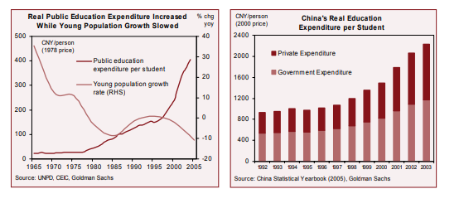

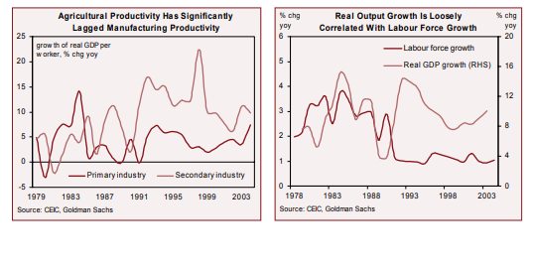

Output Growth Forecast

Economic growth would be affected by a combination of forces,increasing improving human capital and the further release of surplus labour from the agriculture sector. We show in the following analysis that output growth should hold up well

after accounting for the last two factors, as well as a potential easing of the one-child policy.

We project real GDP growth in three scenarios:

Scenario 1 is assumes that China willundergo a modest accumulation of human capital, and sees no change in the urbanization or one-child policy. This estimate is similar to our BRICs projections.

Scenario 2, takes into account the rapid enhancement of education attainment going

forward, and allow rural surplus labourers to migrate freely from 2006.

Scenario 3 deals with an improvement in labour quality and the release of surplus

labour from the agricultural sector, and assumes a phase-out of the one-child policy

fromin 2010, with details consistent with the proposal discussed above.

. Hence, after that we think that Scenario 3 is the most likely of the three scenerio

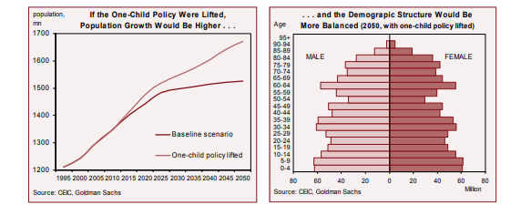

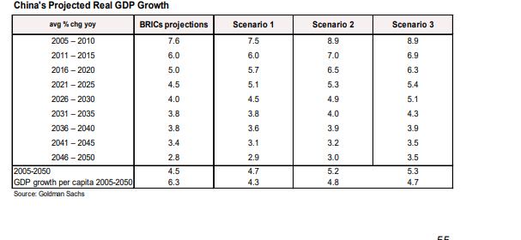

CASE STUDY :( CHINA’S GDP GROWTH)

One of the misconceptions about China is that the economy contains an over-investment, which will soon result in a sharp correction both in investment and GDP growth, resulting a rising non-performing loans (NPLs) and deflation. The reason behind this theory is that fixed asset investment (FAI) is growing above 20% year , while the investment-to-GDP ratio is slightly above 45% moreover, this investment boom is financed by misallocated bank credits Although this is a popular view, we believe it is wrong for two reasons. First, the conclusion is based on macro data, leading to a substantial overstatement of the investment-to-GDP ratio. Second, a high investment-to-GDP ratio is consistent with China ís a rapid growth. The known fact is that the return on capital is high and has been climbed over

the past decade supports our thesis that China ‘s investment strength is sustainable. We think the over-investment issue reflects data quality problems The reported investment-to-GDP ratio looks shocking , but it is significantly overstated due to an over-estimation of investment, under-estimation of consumption and under-estimation of GDP. Data on corporate earnings suggests a very different scenario of health of investment, showing that retained earnings are a key source of investment financing and that the return on investment is not only high but has been rising over decades . This suggests that China can invest much more before its investment returns start to dip.

Policy prescriptions for China can differ fundamentally depending on the diagnosis for

the economy. If the problem is overinvestment with a falling rate of return, then policy should aim to restrain investment growth while promoting consumption and export growth. However, if the real imbalance

is insufficient domestic demand amid rising trade surpluses and robust corporate returns, then the right policy should involve a real appreciation of the currency to smooth the demand rotation away from exports. Other important domestic-demand-friendly policies would seek to alleviate the financial

constraints on consumers and enterprises.

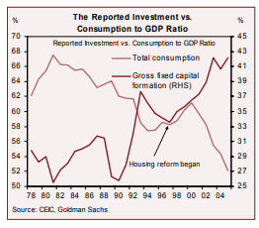

Incompatible investment vs. saving rate

A nation’s savings must equal its investment ex post.

follows:



That is, total national savings equals total investment undertaken domestically plus capital

Investment growth rate

China’s Investment Strength Is Sustainable

exported abroad. Dividing both sides of Equation (2) by nominal GDP, we arrive at the

national savings rate, which equals the investment-to-GDP ratio plus the current account

surplus as a percentage of GDP:

(3)



Two Simple Math Inquiries, One Conclusion

Much of the controversy over China ís excessive investment could be due to the poor

quality of Chinese statistics. Two simple cross-checks on the investment and

national account data cast serious doubts on their quality.

Incompatible GDP growth vs. investment growth

Mathematically, the degree to which investment growth contributes to GDP growth can be

calculated by:



How High Should the Investment-to-GDP Ratio Be?

, we would think that the real investment-to-GDP ratio need to be 40% in order to support China’s 9+% annual growth. The logic is simple: with rapid growth, more investment is needed not only to produce more output but also to replace depreciated capital equipment. The level of investment to GDP is linked to an economy’s stage of development. Which it tends to rise for countries during their period of fastest growth, as their total capital-stock-to output and capital-stock-to-labour ratio. With some extent, a

rising investment-to-GDP ratio itself could simply be a manifestation of the normal capital

accumulation process.

China has a long way to go to accumulate more capital

Inspite of 27 years of fast growth, China remains a

low-income country on a per capita basis, with as many as country’s about 1.3 billion people underemployed in rural areas. Therefore, it is not surprising to find that China’s capital-to-labour

ratio is still a fraction as compared to that in the US and Japan, while the capital-to-output ratio is in the range with the US, but below Japan. Further capital deepening is a crucial part of the development process. Our BRICs research find that, by around 2035, the size of the Chinese economy may be 17 times what it was in 2004 in nominal US Dollar terms (or six times in real CNY terms), and may surpass the US Assuming the capital-stock-to-output ratio stays at constant until then, China could need to expand its total capital stock by 11 times in terms of US Dollar. if the capital-stock-to-GDP ratio needs to rise further in the the investment-to-GDP ratio would need to be further higher

Investment Does Not Appear to Have Overshot the Rate of Return

. It is the efficiency of investment which ultimately holds the key to the sustainability question. We believe actual data on returns at the corporate level provides very useful information on whether China has invested too much without profit, particularly given the flaws in macro data.

Beyond financial data from Chinese companies listed overseas (including in Hong Kong,

Singapore, New York and London), we also study in detail the industrial enterprise financial

statistics complied by the National Bureau of Statistics (NBS). This data covers about 200,000

listed and provides useful and reliable information on corporate .We believe on NBS-reported profit data which is a good indicator of corporate profitability, results are not audited according to international accounting standards. Since companies paid tax on their reported profits, the incentives to

over-report should be limited.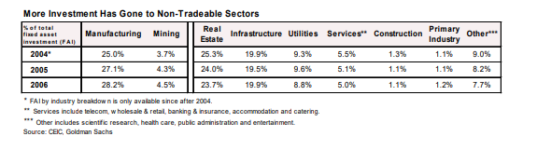

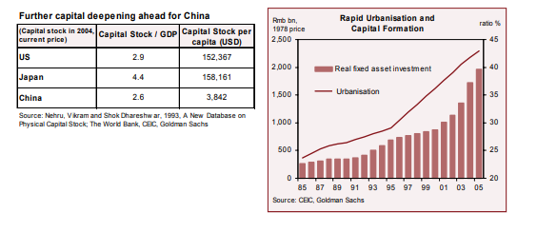

**Trade**

**Case study(RCEP):**

**Why India back of from RCEP?**

**Production**

**Three sector of production industry,agriculture and service:**

Conclusions

No doubt better investment can be attained through better cyclical management and much more

forceful financial-sector reforms. We believe the main challenge facing China in the next two

to three years will be whether it can switch its 6%-7% current account surplus towards

domestic demand without creating either a cyclical boom-bust or medium-term risks to its

financial system.

On other hand , we believe that nominal currency appreciation is the most efficient policy

tool for curtailing domestic inflationary pressures in the process of investing much more

domestically and helping international demand adjust smoothly. The currency regime shift and

the modest appreciation since July 2005 are unambiguously positive for the economy.

However, bolder actions are much needed before China can truly reduce its reliance on its external

demand and develop monetary policy independence.

The challenges of financial-sector reform much more difficult and complex. There is clear room

for further improvement in the allocation and use of capital. Undoubtedly quite few SOEs are

still loss-making and China capital markets remain significantly underdeveloped.

Even here, however ,we find that recent developments have been mostly positive:

financial-sector reforms

have apparently accelerated, as has currency reform. In addition, the government seems to

have realised the importance of domestic demand and the risks associated with a rising trade

surplus. If China continues to reform, deregulate and become more efficient in the next few years, as it has done in the past 27 years, it should benefitted

